Cite document as: Braukmann, Van den Eynden & Leenarts (2020). The CESSDA Management Expert Guide -Tips for Trainers [handout]. Bergen: CESSDA ERIC.
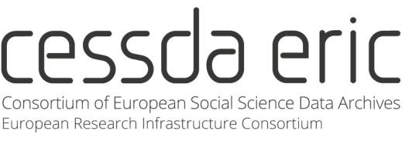

The CESSDA Data Management
Expert Guide General information

Background
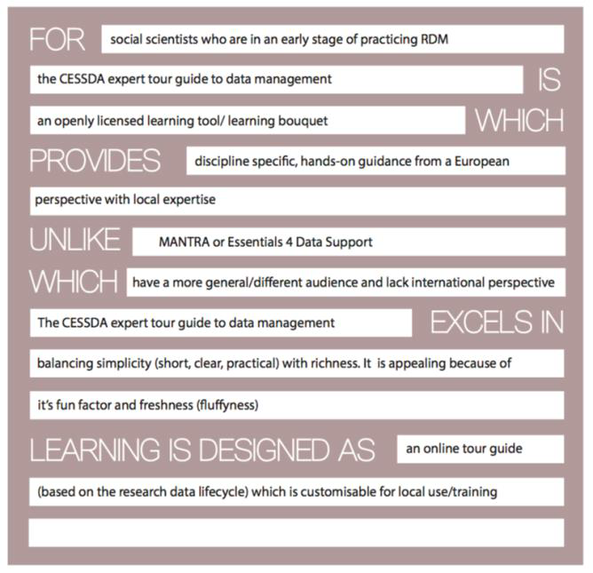
The Data Management Expert Guide (available via https://www.cessda.eu/DMGuide) by CESSDA ERIC is an online training module aimed to put social scientists at the heart of making their research data findable, understandable, sustainably accessible and reusable. The module was developed in 2017 by several CESSDA archives (ADP, AUSSDA, CSDA, DANS, FORS, FSD, GESIS, NSD, SND, So.Da.Net and UKDS) and illustrated and edited by Verbeeldingskr8.
During a one-year project, the CESSDA archives combined all the knowledge and expertise on research data management (RDM) that was available locally within one comprehensive online training. The module is designed to cover all aspects of RDM and includes best practices, as well as practical tips, and information about European diversity in data management.
Target audience
The Expert Tour Guide is designed for
(early career) social sciences researchers
who want to learn more about RDM.
It was created in collaboration with young researchers who provided feedback on the
structure and the content of the module at two points in time during the development
process. Next to being a stand-alone self-study module, the Expert Tour Guide can also be
used by trainers as a basis for interactive workshops and courses.
Product statement of the Data Management Expert Guide defining - amongst others- the target audience of the module.
Structure of the module
The Expert Tour Guide follows the Research Data Life Cycle and is divided into seven chapters that deal with the different aspects of a (typical) research project.

Parkveien 20 5007 Bergen Norway

(+47) 55 58 36 48 cessda@cessda.eu www.cessda.eu
Cite document as: Braukmann, Van den Eynden & Leenarts (2020). The CESSDA Management Expert Guide -Tips for Trainers [handout]. Bergen: CESSDA ERIC.

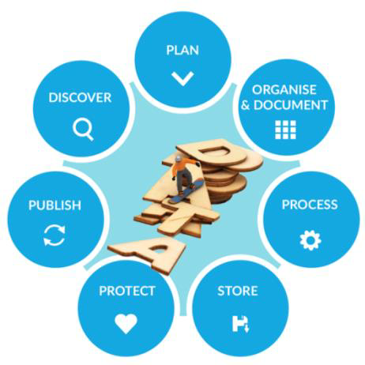
To establish a common look and feel for the module
across the different chapters, a professional designer
created images and elements visualizing the module
content. In addition, four recurring elements were
used throughout the module:
» Expert Tips. Each chapter contains tips that
provide the reader with food for thought and
practical how-to information.
» European diversity. Where applicable, differences
between European countries are discussed in the
chapters.
» Qualitative vs. Quantitative data. Then
module contains in-depth tips on how to
deal with specific type (i.e., qualitative
or quantitative) of data.
The Research Data Life Cycle used in the Expert Tour Guide. Please note that the Discover Chapter will be added at the end of 2018.
» Adapt your DMP. The final section of every chapter summarizes a couple of questions
that researchers should consider when preparing a data management plan (DMP). We
have designed a list of all DMP-questions that can be answered using the insights from this Expert tour guide on Data Management and it can be viewed and downloaded at the beginning of the module.

How the module can be used
Self-study by researchers
The Expert Tour Guide can be used as a stand-alone self-study module for researchers. It
contains between 15 to 20 hours of materials that should give (young) scientists a solid basis of the most important aspects of data management.
Building block for interactive training
In addition, the Expert Tour Guide can also be used by trainers or data stewards in (social
sciences) research institutes to provide workshops on data management. We have
developed a train-the-trainer package that contains different materials which trainers can
use in such workshops. More information on this package can be requested via
training@cessda.eu
License
The Expert Tour Guide on Data Management by CESSDA ERIC is licensed under a Creative
Commons Attribution-ShareAlike 4.0 International License. All material under this license
can be freely used, as long as CESSDA ERIC is credited as the author.

Parkveien 20 5007 Bergen Norway

(+47) 55 58 36 48 cessda@cessda.eu www.cessda.eu

