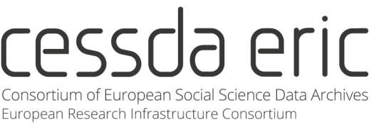

The CESSDA Data Management Expert Guide
Tips for Trainers

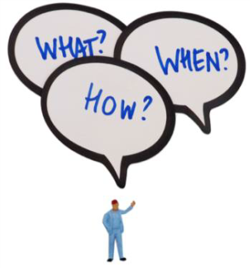
This document contains a collection of tips for trainers who
want to give a one-day RDM workshop for researchers.
In general, a workshop should be designed to encourage active
learning by making processes visible, containing practical
exercises and room for critical reflection and discussion.
Below, we offer some concrete examples of what worked well
for our trainers.
Target audience
» For a one-day hands-on workshop, groups of 20 - 30 researchers usually work well
» It can be useful to limit the audience to junior researchers, but a mixed audience (of
experienced researchers, junior researchers and data support staff) can be very useful, as participants contribute different experiences to the discussions
» We tend not to restrict the discipline of the audience but rather indicate that our training is suitable for all researchers who do research with people.
Workshop set-up
» Introduction: Starting the day with a short introduction round to get to know each other.
If the group is too big, online polling systems (like Mentimeter) may work to get some
information on the group.
» Presentations: Keep the presentations short and interactive. Try and vary presenters, for example, think of inviting experts on specific topics, researchers who present their
experiences, demonstrate specific tools, etc.
» Exercises: Select concise exercises and plan enough time. To encourage interaction, have break-out sessions or small group discussions followed by a panel discussion where key findings are discussed.
» Plan in time for a round-up session at the end of the workshop.
» Preparation: It can be useful to ask participants to read background literature, prepare
small exercises or send materials beforehand which can then be used during the
workshop.
» Instead of labelling your workshop RDM, you can also try and focus on a specific
challenge or problem researchers have and invite a speaker from the field that can share his/her experience.

Parkveien 20 5007 Bergen Norway

(+47) 55 58 36 48 cessda@cessda.eu www.cessda.eu

Engagement with participants
» You can ask participants beforehand to send questions or topics they would like to
discuss or have them send materials from their own research (e.g., a DMP or an example consent form).
» Try to get people off their chairs, for instance by throwing a ball from one person to the next during the introduction round.
» During group work, move around the room to listen in and ask what is being discussed in the different groups.
» Live polling (for instance Mentimeter) can be useful to create interaction and discussion in particular with a larger audience.
Practical matters
» Always offer lunch or pizza!
» Announce the workshop well in advance, e.g., in local university newsletters and provide a
clear workshop program in the announcement.
» Assess the workshop room beforehand to ensure that it is a nice room that fits for a
workshop and group work and that all equipment (internet, power for laptops) is available.
» Plan enough time for (lunch) breaks and for sessions to run over.
» Make slides and handouts available (afterwards) to participants.
» Prepare an evaluation round or form to receive feedback from participants.
→ Be creative and adapt exercises and examples to suit your audience and your purposes.
Useful links for further reading and trainer material
» https://carpentries.github.io/instructor-training/22-practices/
» http://galaxyproject.github.io/training-material/topics/training/tutorials/good-practices/slides.html
» https://www.mygoblet.org/training-portal/materials/train-trainer-course-materials
» https://open-science-training-handbook.gitbooks.io/book/content/
To available exercises
» Dataone: https://www.dataone.org/education-modules
» UKDS: https://www.ukdataservice.ac.uk/manage-data/handbook
To training websites
» https://www.fosteropenscience.eu/resources
» https://www.ukdataservice.ac.uk/manage-data/training

Parkveien 20 5007 Bergen Norway

(+47) 55 58 36 48 cessda@cessda.eu www.cessda.eu

